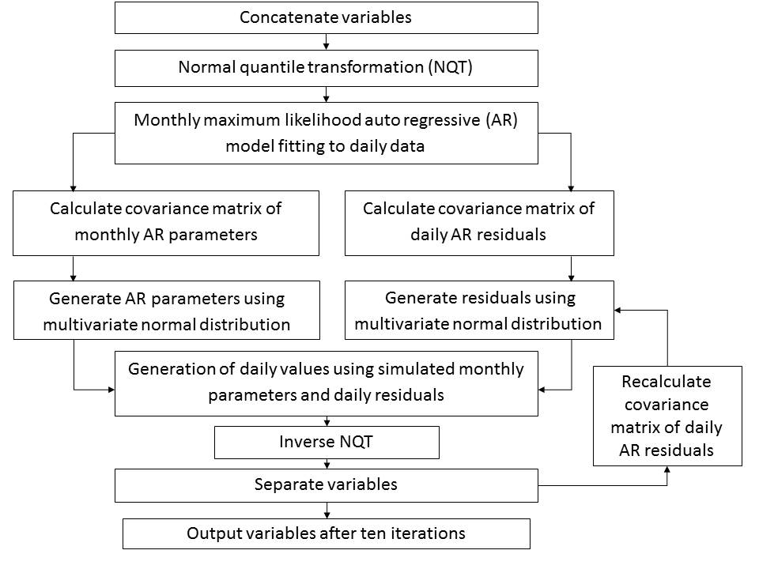
Figure 1: Schematic of simulation procedure.

Figure 2: Daily mean of T_{app} for each month for the IMAGE simulation and the input CORDEX data for 1971-2000. Vertical lines show the range across the ensemble for IMAGE simulation, where each ensemble member has a length of 30 years. [[[to replace]]]

Figure 3: Daily standard deviations of T_{app} for each month for the IMAGE simulation and the input CORDEX data for 1971-2000. Vertical lines show the range across the ensemble for IMAGE simulation, where each ensemble member has a length of 30 years.
Figure 4: PDFs of SPEI for each month for the IMAGE simulation (grey) and the input CORDEX data (black) for 1971-2000.

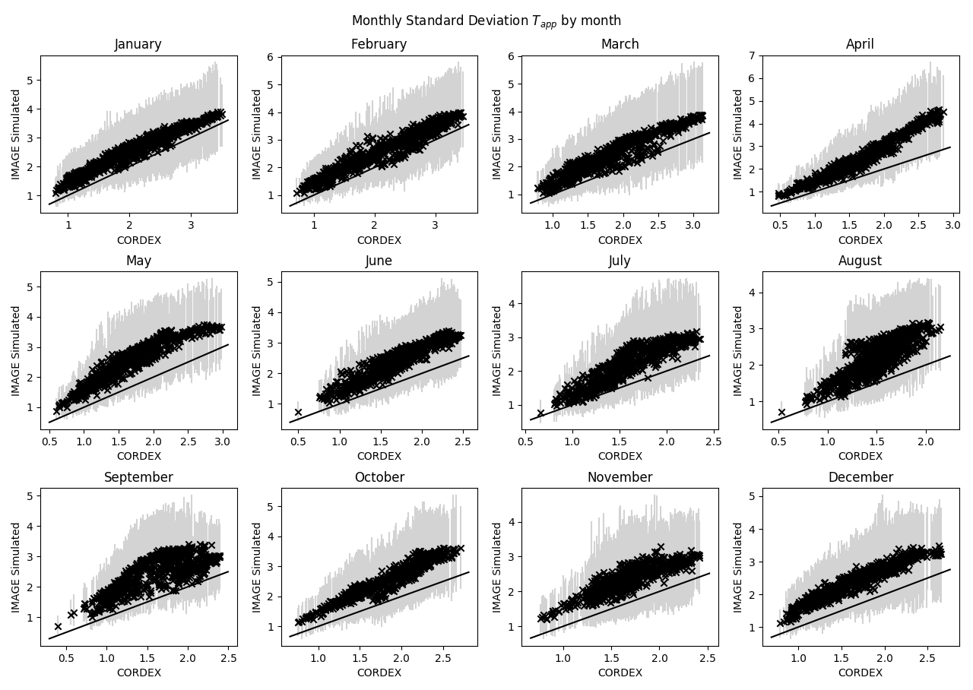
Figure 5: Monthly standard deviations of T_{max} and T_{app} for each month for the IMAGE simulation and the input CORDEX data for 1971-2000. Vertical lines show the range across the ensemble for IMAGE simulation, where each ensemble member has a length of 30 years.

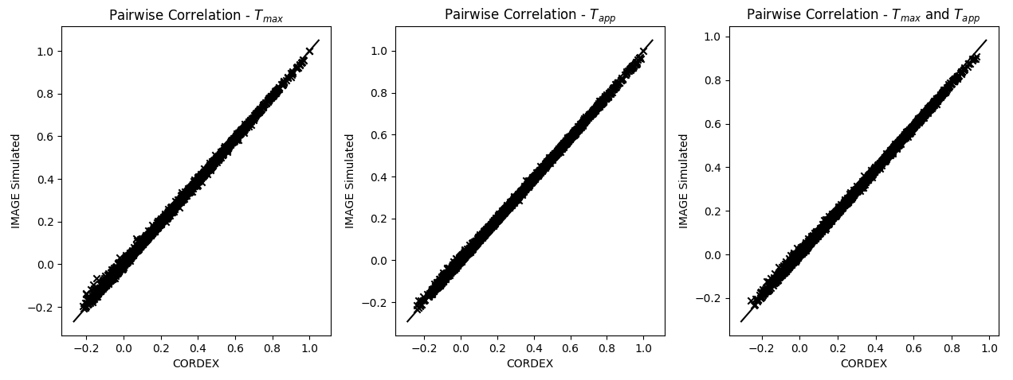
Figure 6: Pairwise Pearson’s correlation coefficient for T_{app}, SPEI, and cross-correlation between T_{app} and SPEI for the IMAGE simulation and the input CORDEX data for 1971-2000.
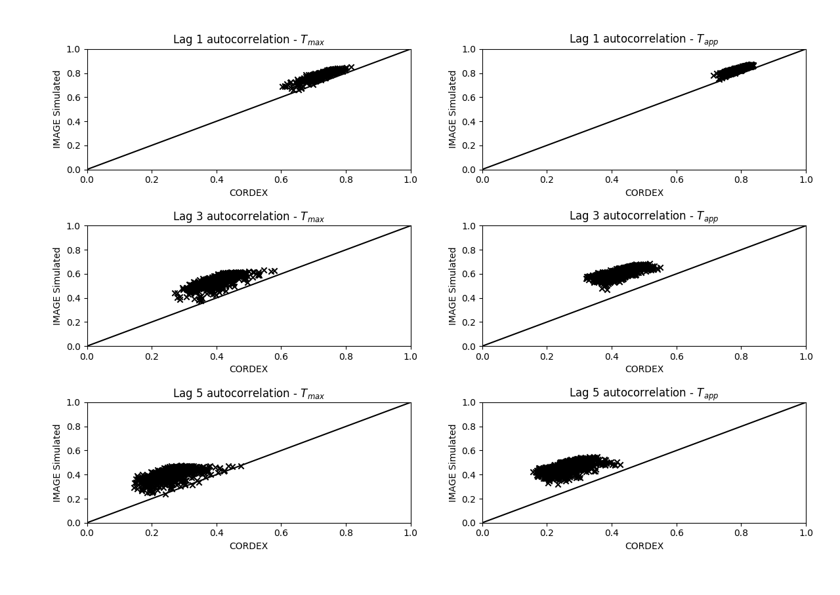
Figure 7: Autocorrelation of T_{app} for lags of 1,3 and 5 days respectively for the IMAGE simulation and the input CORDEX data for 1971-2000.

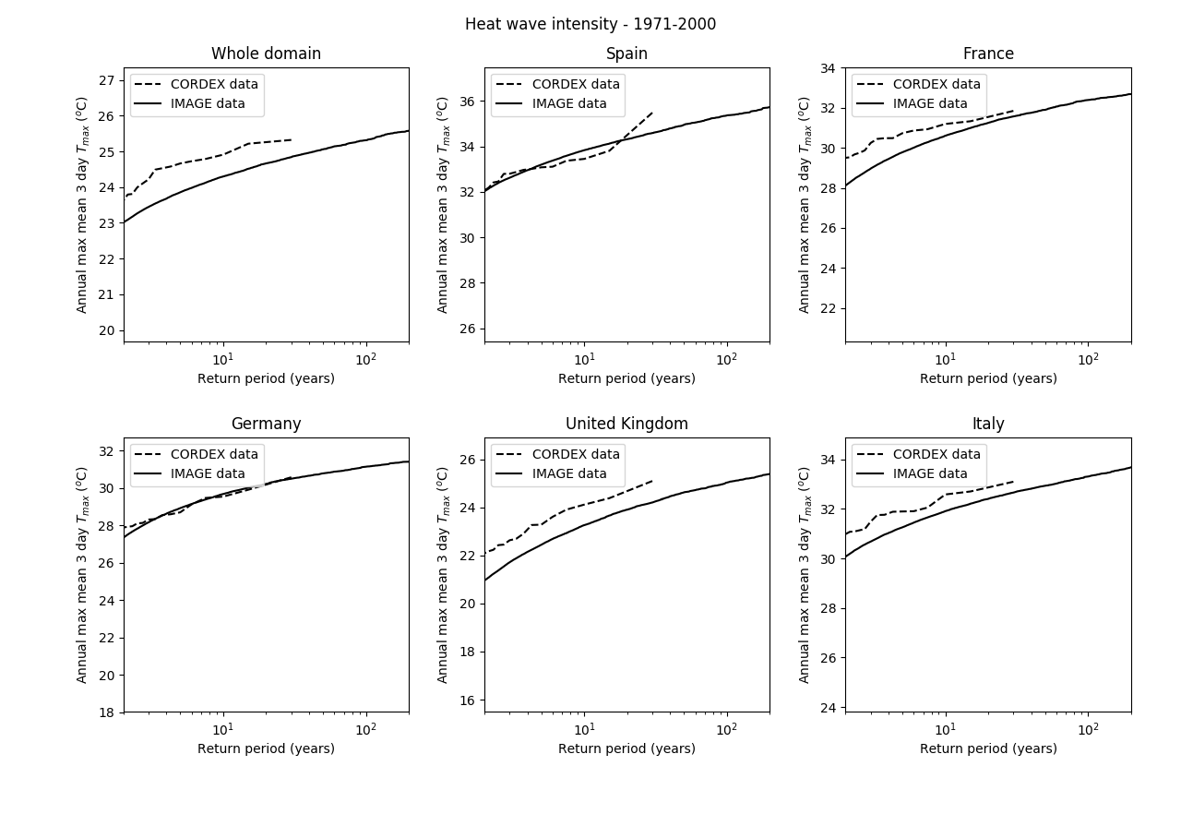
Figure 8: Return value of heat waves, as measured by intensity, for the whole domain and five countries within the domain for the IMAGE simulation and input CORDEX data for 1971-2000.

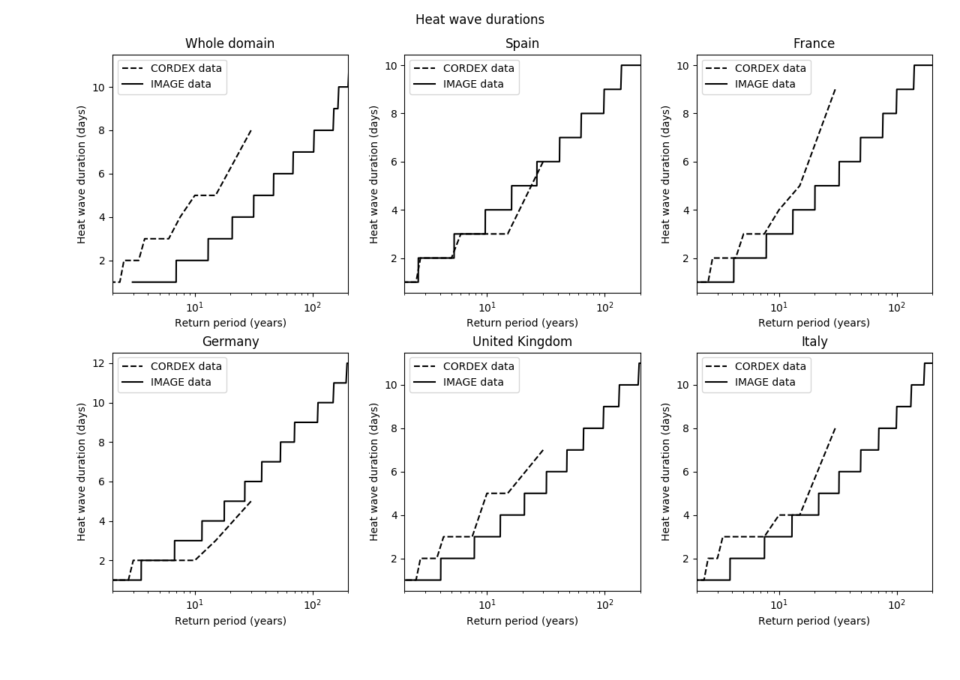
Figure 9: Return value of heat waves, as measured by duration, for the whole domain and five countries within the domain for the IMAGE simulation and input CORDEX data for 1971-2000.

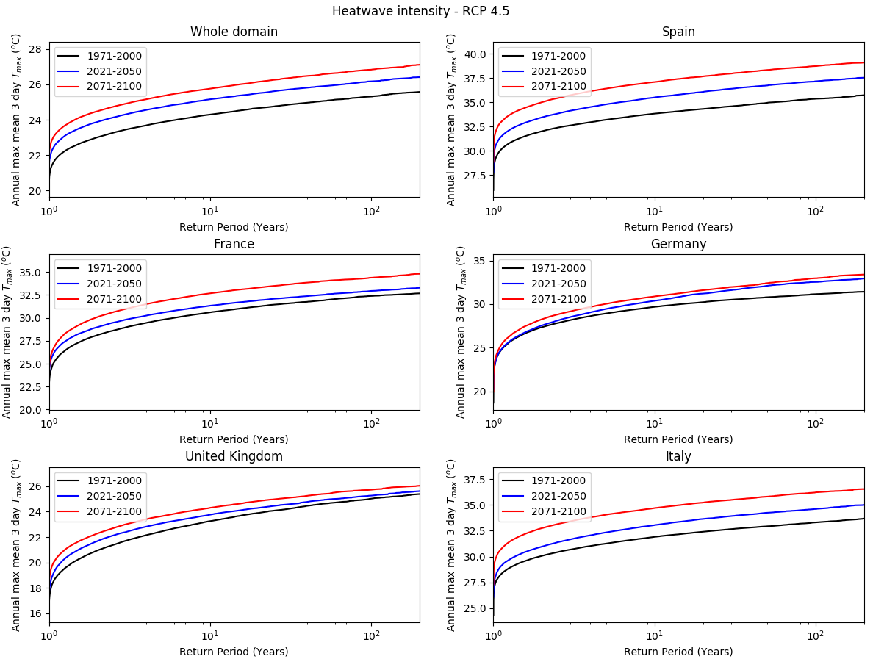
Figure 10: Return values of heat waves, as measured by intensity, for the whole domain and five countries within the domain for the IMAGE simulation under the RCP 4.5 scenario.

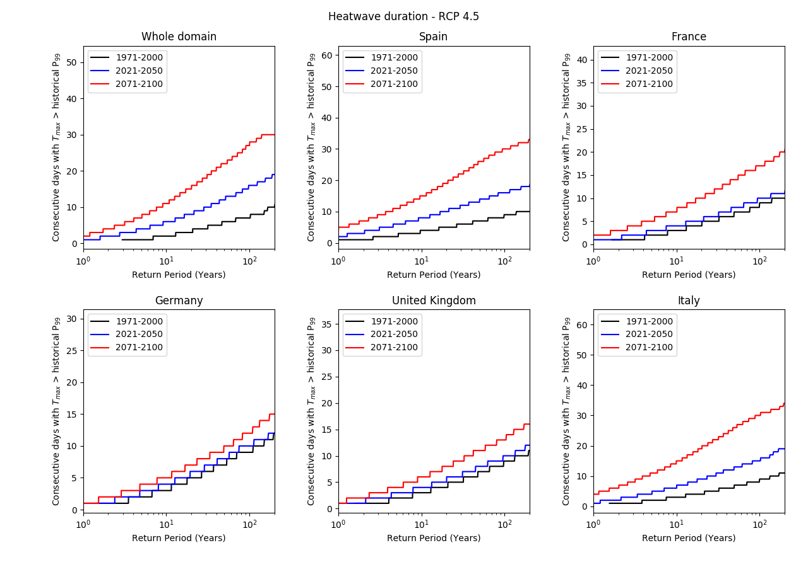
Figure 11: Return values of heat waves, as measured by duration, for the whole domain and five countries within the domain for the IMAGE simulation under the RCP 4.5 scenario.

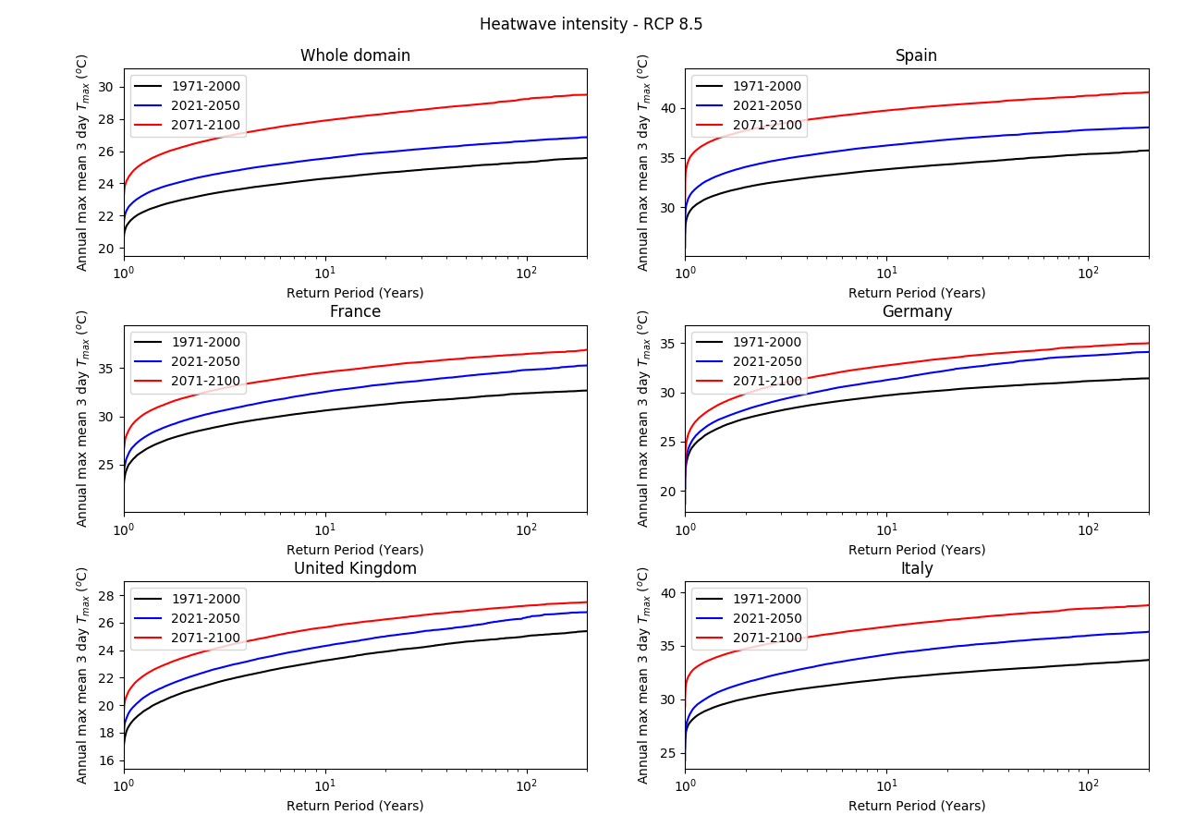
Figure 12: Return values of heat waves, as measured by intensity, for the whole domain and five countries within the domain for the IMAGE simulation under the RCP 8.5 scenario.

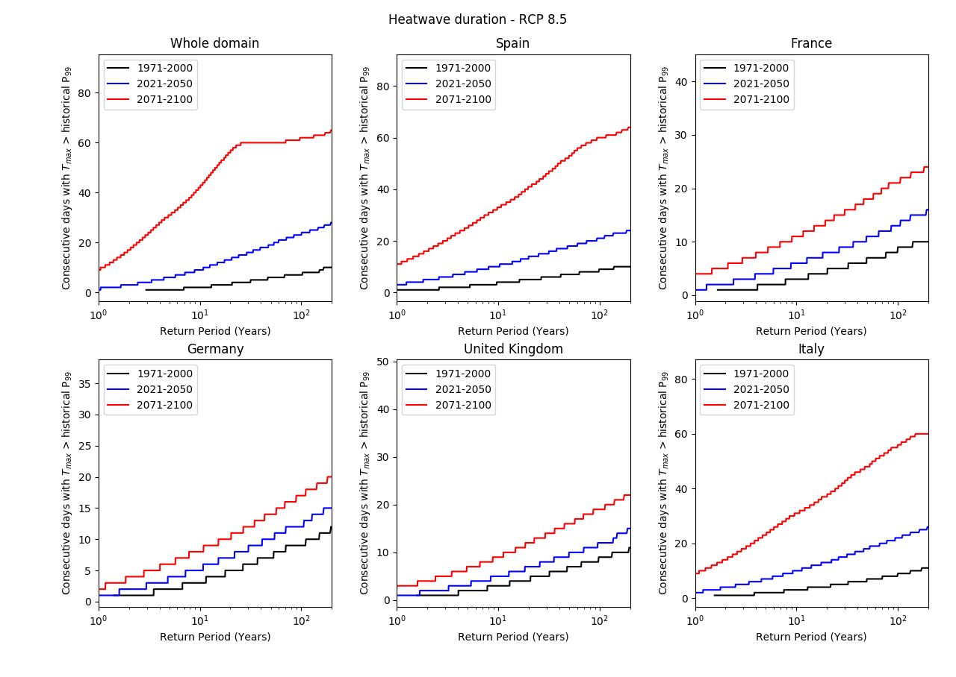
Figure 13: Return values of heat waves, as measured by duration, for the whole domain and five countries within the domain for the IMAGE simulation under the RCP 8.5 scenario.

Figure 14: PDFs of SPEI for each month for the IMAGE simulation (grey) and the input CORDEX data (black) for 2021-2050.

Figure 15: PDFs of SPEI for each month for the IMAGE simulation (grey) and the input CORDEX data (black) for 2071-2100.

Figures 16-19: As Figures 10-13 but with SPEI

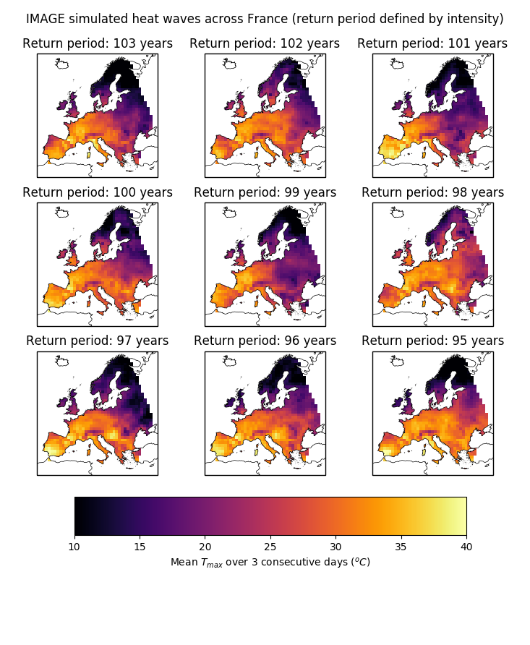
Figure 20: Maps of mean T_{max} over 3 consecutive days across Europe for heat waves in France, as measured by intensity, with return periods between 95 and 103 years.

Figure 21: Maps of SPEI lower than -2 across Europe for droughts in France, with return periods between XX and XX years.

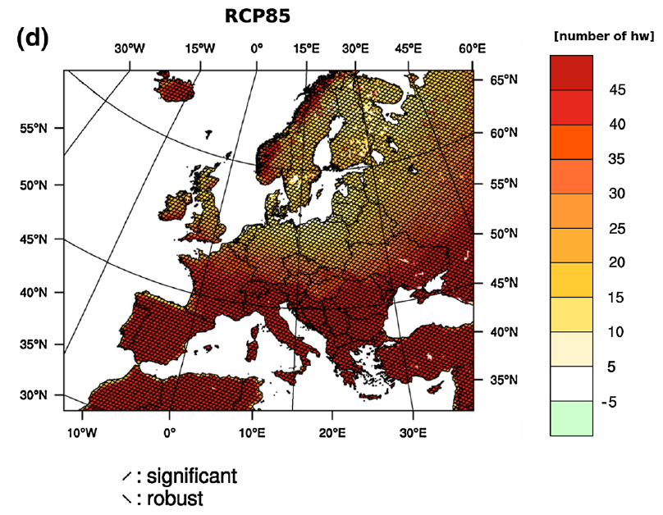
Figure 22: Reproduced from Jacob et al (2014); map of the ensemble mean number of additional heat waves for the period 2071-2100 compared to the period 1971-2000 for the CORDEX experiment under the RCP 8.5 scenario.
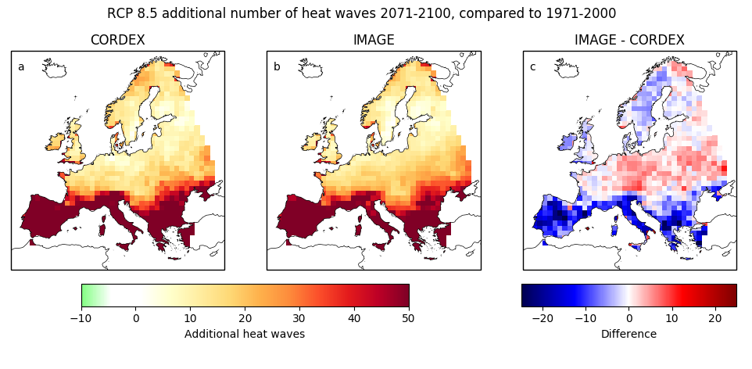
Figure 23: Additional number of heat waves in the period 2071-2100 compared to the period 1971-2000 under the RCP 8.5 scenario, for (a) the input CORDEX data and (b) the IMAGE simulation, as well as (c) the difference between the number predicted by the IMAGE simulation and the input CORDEX data.

